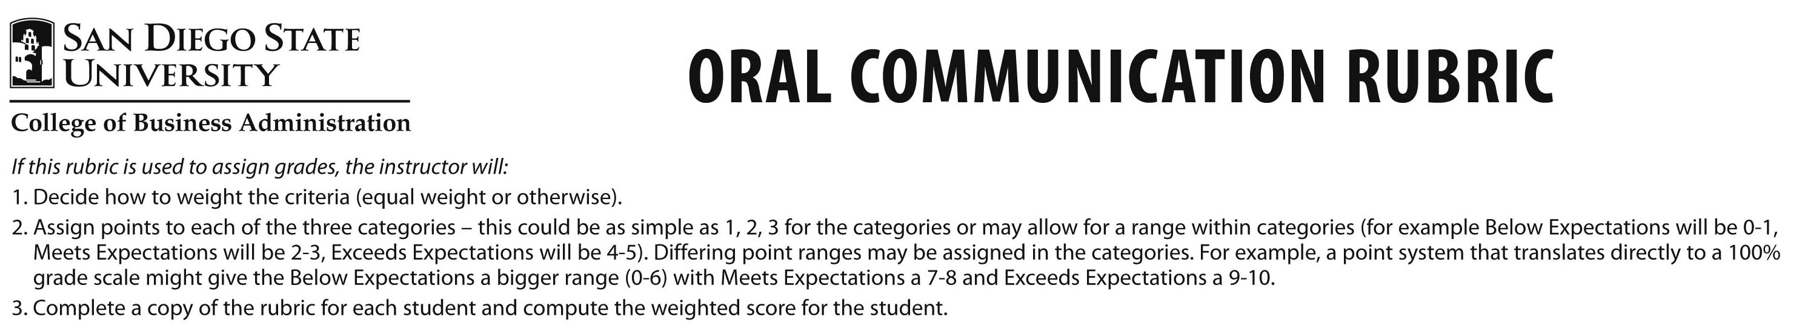
 | Below Expectations | Meets Expectations | Exceeds Expectations
Organization | No opening and/or closing statements or irrelevant opening/closing statements. Loses focus more than once. Does not manage time effectively. No logical sequence of information. Mechanistic. | Offers some type of opening and closing statements. Follows logical sequence but structure could be better. May need more elaboration on one or more points. Adequate time management, but could be stronger. | Clear opening and closing statements. Catches audience’s interest, provides overview/conclusion. Follows logical sequence, stays focused, good explanations. Effective time management and strong transitions. Strong mental take away for audience.
Voice Quality & Pace | Mumbles, mispronounces words, grammatical errors, “umms”. Difficult to understand. Speaks too quietly or too loudly. Speaks too fast or too slow. Loses train of thought, tentative. Lacks enthusiasm. | Easily understood. Speaks loud enough to be heard and at appropriate pace. Some awkward pauses or halting delivery but mostly clear and natural. Could display greater enthusiasm, seem more genuinely interested in own presentation. | Enthusiastic and engaging. Speaks clearly and loudly enough at a comfortable pace. Exudes confidence and interest. No grammatical or pronunciation errors. Presentation appears conversational, extemporaneous, and natural.
Mannerisms & Body Language | Demonstrates distracting mannerisms which may include bad posture, shifting feet, too much or too little hand movement. Body language reveals reluctance to interact with audience. Seems fearful/very nervous. | No significantly distracting mannerisms. Acceptable posture. Body language mostly demonstrates comfort in interacting with audience but occasional instances of discomfort may be communicated. Seems natural for the most part. | Body language used effectively to maintain audience’s interest. Body language reflects presenter’s reaction to, and empathy with, the audience. Gestures match verbal content, are comfortable and relaxed, seem spontaneous.
Professionalism & Appearance | Does not meet minimum requirements for business dress. Makes excuses for aspects of the presentation. Inappropriate word choice for audience. Inappropriately informal. | Meets minimum standards for business dress and appearance. Generally treats audience professionally, acceptable word choice (no slang). May seem to lack confidence at times. Reasonably credible. | Dressed appropriately. Appearance engenders respect and credibility. Treats audience professionally. Speaker appears confident and has good command of the topic.
Rapport with Audience & Use of Media | Does not connect with audience. Little to no eye contact. Reads. Relies heavily on slides and/or notes. Attempts to cover too many slides or lingers too long on too few slides. | Tries to maintain eye contact most of the time but instances may be fleeting in length. Scans the room. Some reliance on notes or slides. | Genuinely connects with audience. Maintains eye contact throughout. Visuals (slides, etc.) effortlessly enhance speech.
Updated January 2009
Credits: This document borrows from the SPEAKS Rubric from CSU-Fullerton Business Communication Program and the CSU-Chico, College of Business Oral Communication Rubric.

